LAB No 9 Study of Domain Name Server

Date: 25.10.23

Objectives:

• To illustrate the significance of Domain Name Server

• To Study the information exchanged between DNS and Clients

LAB EXERCISES

1. Configure the below topology to setup DNS server. R1 will use R2 as DNS server to make

DNS resolutions.

First, lets begin with R1. We’ll setup hostname and IP related information.

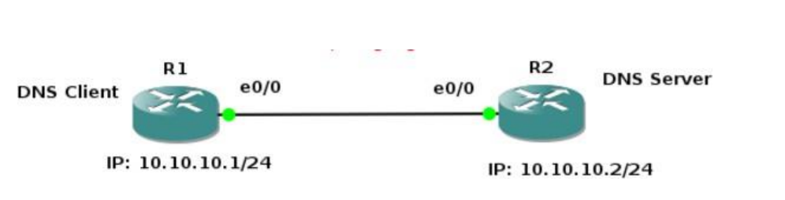

Steps:

1. **R1 IP configurations:**

Enable

configure terminal

hostname R1

interface e0/0

ip address 10.10.10.1 255.255.255.0

no shutdown

end

1. **R2 IP and Hostname Configurations**:

enable

config t

hostname R2

int e0/0

ip address 10.10.10.2 255.255.255.0

no shutdown

end

1. **Setting up R2 as DNS Server**

config t

ip dns server

ip host loopback.R2.com 2.2.2.2

We mapped loopback.R2.com to ip address 2.2.2.2. Currently, we don’t have 2.2.2.2, we could

create loopback interface on R2 and assign ip 2.2.2.2.

interface loopback 1

ip address 2.2.2.2 255.255.255.255

end

Let’s verify that loopback interface we just created is working. This will show us that the

hostname correctly setup locally on R2.

ping loopback.R2.com

Now it’s time to setup R1 to resolve hostnames using R2**.**

1. **On R1 type;**

config terminal

ip domain lookup

ip name-server 10.10.10.2

Set R1 to use R2 as default gateway to get to loopback interface on R2. So that after R1

resolves loopback.R2.com, it can reach 2.2.2.2 through its default route (R2).

1. **on R1 type:**

config t

ip route 0.0.0.0 0.0.0.0 10.10.10.2

end

This tells our router that to get to any network not in it’s routing table, it’s next hop is 10.10.10.2

which is our router R2.

1. Now on R1, do a ping to loopback.R2.com and you should get a success message.

ping loopback.R2.com repeat 3

1. Captured the traffic using Wireshark.

Lab 10: STUDY OF DHCP PROTOCOL

Objectives:

• Understand DHCP Service

• Analyzing DHCP Packets

• Understanding significance of Netmask value

LAB EXERCISES

Configure two VMs that will be used to test connectivity from end to end and R1 will

serve as a DHCP server to distribute IP addresses. The diagram below details the

current setup:

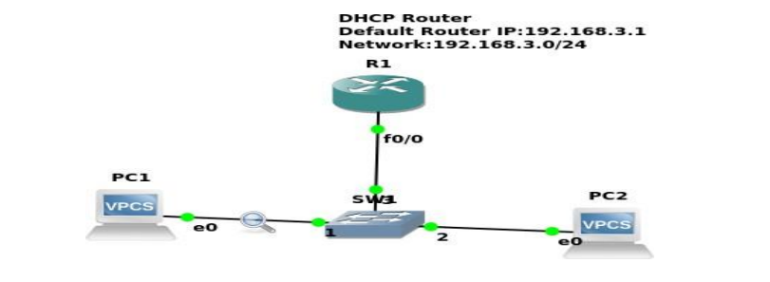

1. In order to configure our router as a DHCP server the following commands were used.

R1(config)#IP dhcp pool NAME

R1(dhcp-config)#Network 192.168.3.0 255.255.255.0

R1(dhcp-config)#Default-router 192.168.3.1

2.The next thing that you want to do is configure the fastethernet 0/0 interface which will

connect to our switch.

R1(config)#Interface fastEthernet 0/0

R1(config-if)#No shutdown

R1(config-if)#ip address 192.168.3.1 255.255.255.0

The commands above will turn the interface on and assign an IP address.

3. Turn on the VPCS. In PC1 and PC2 type dhcp

PC1>dhcp

PC2>dhcp

4. Execute show ip route

4. Let’s analyze some of the traffic patterns using Wireshark